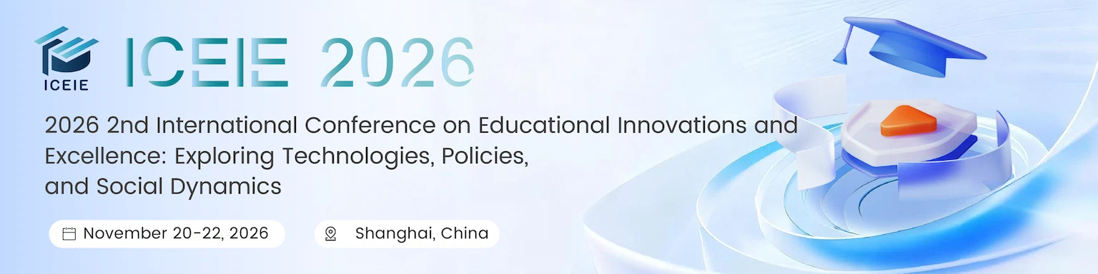
Track 1: Educational Technology and Innovation
Application of Artificial Intelligence in Education
Development of Educational Software and Mobile Learning Platforms
Integration of Virtual Reality and Augmented Reality in Teaching
Design of Distance Education and Online Courses
Educational Big Data Analysis and Learning Analytics
Educational Robots and Automated Tools
Blockchain Technology in Education and Digital Certification

Track 2: Education Policy and Practice
Global Trends and Challenges in Education Policy
Strategies for Educational Equity and Inclusion
Professional Development of Teachers and Lifelong Learning
School Management and Leadership Cultivation
Curriculum Design and Assessment Methods
Cross-cultural Education and International Cooperation
Educational Finance and Investment Benefit Analysis
Case Studies of Educational Reform

Track 3: Education in the Context of Society
Socioeconomic Factors in Educational Outcomes
Education and Social Mobility
The Role of Education in Cultural Preservation and Transformation
Education and Community Development
The Impact of Globalization on Educational Systems
Education and the Digital Divide
Education for Sustainable Development
The Influence of Media and Technology on Student Values and Behavior

Track 4: Education and Educational Psychology
Mental Health in Education
Child Development and Early Education
Educational Assessment and Evaluation Methods
Student Motivation and Learning Strategies
Applications of Psychology in Education
Gender and Education
Educational Equity and Social Justice
Adolescent Psychological Development and Education
Cognitive Development in Educational Settings
Psychological Interventions for Learning Disabilities
Peer Relationships and Academic Outcomes
Parenting Styles and Their Influence
Neuroscience Applications in Educational Psychology
Cultural Influences on Learning and Development

